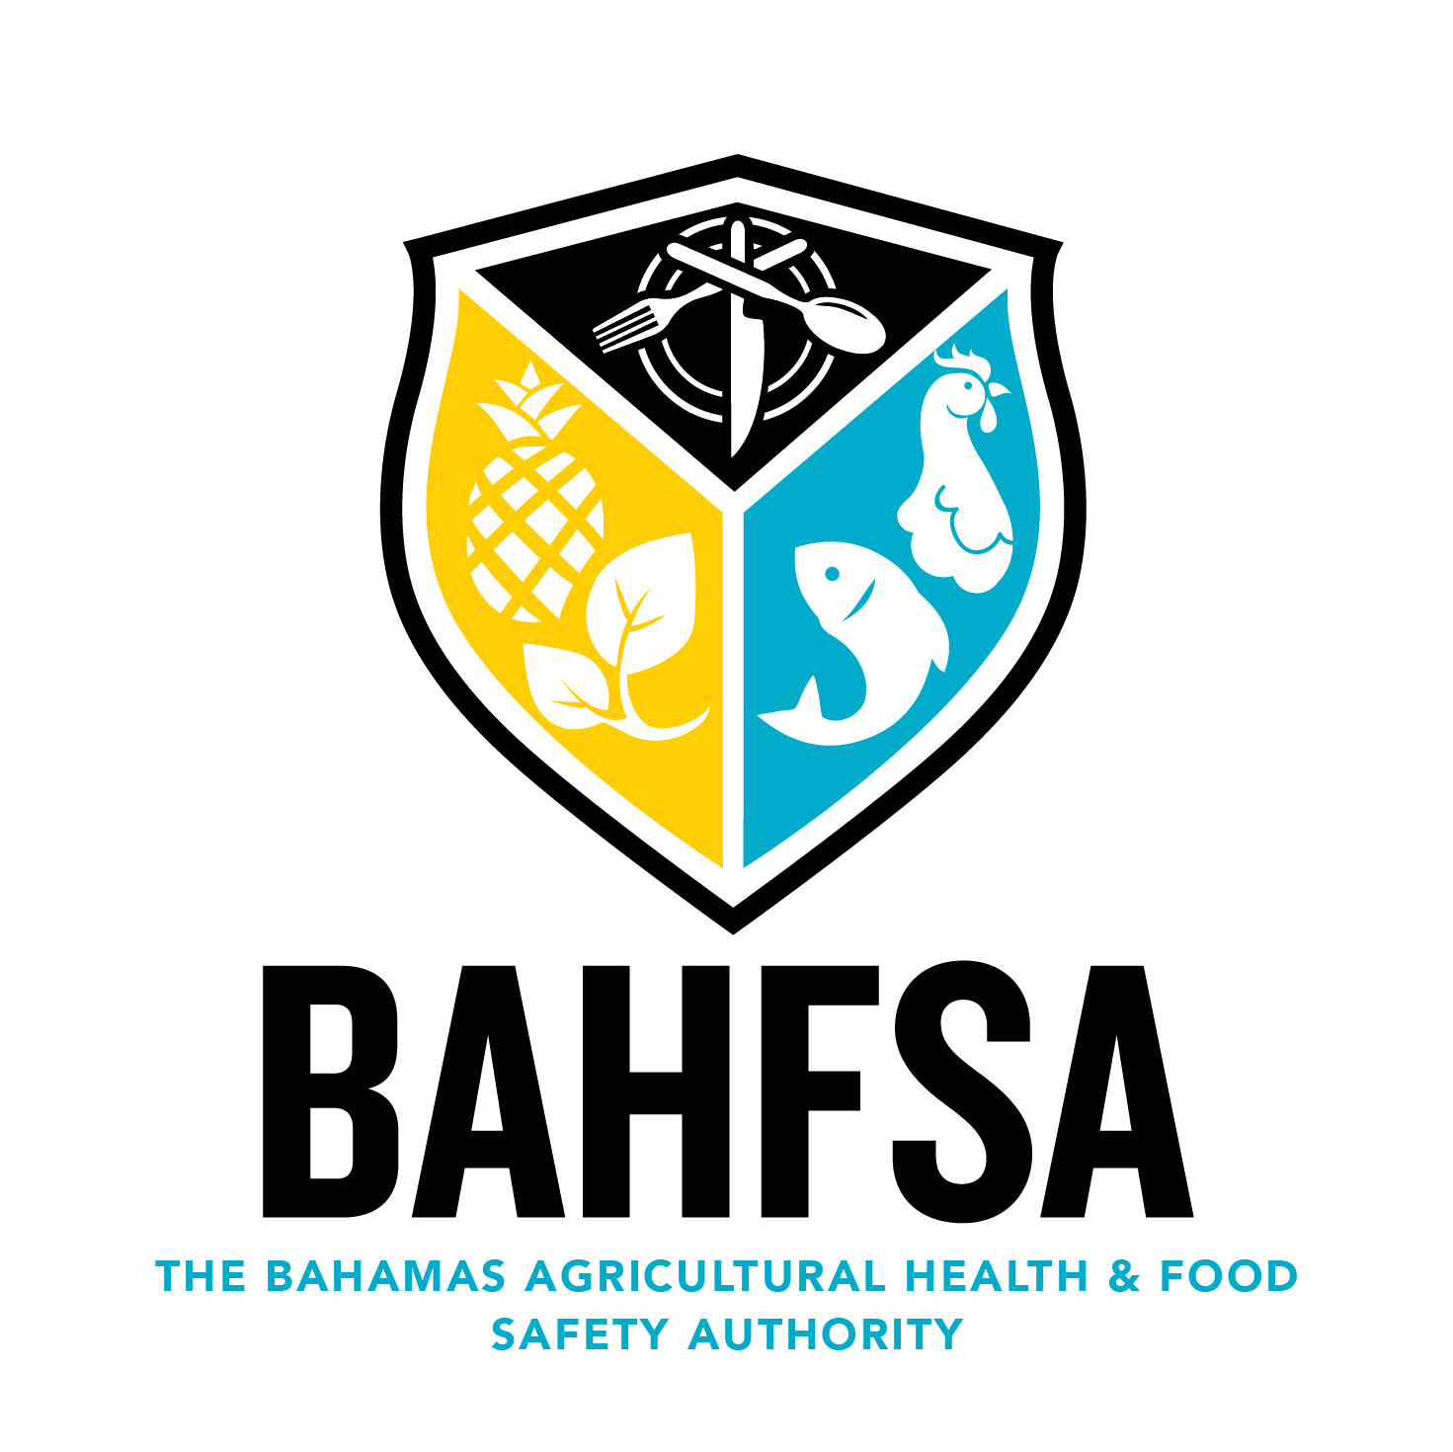

APPLICATION FOR THE REGISTRATION OF A FOOD BUSINESS ESTABLISHMENT
(Food Safety and Quality [FSQ] Act (2016), Part IV, Section 26)
to be assigned for 1st time registrants
Food Business Registration #

This form should be completed by all food business operators (FBOs) at least 30 days prior to opening for business, whether for the first time or renewing a registration. Upon approval, a certificate of registration will be issued which is a pre-requisite for obtaining a business license.

Food Business Details:

- Trading Name: Reg. # if renewing:

Bus. Lic. if renewing:

- Business Address: Business Ph:

- Head Office of Business if different from Business address:

- If mobile, address where business is housed: Ph: for mobile business:

- Primary Business Owner(s) Name: Owner Ph:

Co-Owner/Partner: Co-Owner/Partner Ph:

- Business Owner email: Owner P.O. Box:

- Manager Name: Manager Ph:

- Manager email:

- Number of full-time staff:

- Company vehicle, if applicable (Make and Model):

- Vehicle license number:

- Address where vehicle is stored:

- Type of Food Business (check only ONE that best describes your business):

___ Staff restaurant/canteen/kitchen ___ Hospital/residential/home/school

___ Retailer ___ Distribution/warehousing

___ Restaurant/café/snack bar/deli ___ Food manufacturing/processing

___ Market/market stall ___ Importer/exporter

___ Takeaway ___ Catering

___ Hotel/pub/guest house ___ Packer

___ Private house used for a food business ___ Mobile establishment

___ Wholesale/cash and carry ___ Primary producer – livestock

___ Food Broker ___ Primary producer - crop

___ Other (Please give details):

- If applying for a new business registration, indicate date you intend to open:

- Signature of Business Owner:

- DATE:

SUBMIT FORM for online use only

GUIDELINES

- Under Part IV, Section 26 of the Food Safety and Quality (FSQ) Act, 2016, Any person who is desirous of operating a food business shall:
a. make an application to the Director to be registered using the prescribed form; and
b. pay the prescribed fee;

- The fee for the registration of a food business is $50BSD. Registration of a food business cannot be refused; waived until January 1, 2022

- Once the food business satisfies the conditions of registration, a registration certificate will be issued with a unique identification number, specifying such items and conditions as the Director deems necessary;

- A certificate of registration shall be valid for a year and subject to renewal upon payment of the requisite fee; starting in 2022

- The granting of a certificate of registration shall be a pre-condition to the issuance of a business license under the Business License Act (No. 25 of 2010)

- Any person who operates a food business without being registered commits an offence and is liable to a fixed penalty as prescribed by the Food Safety and Quality Regulations;

- A list of registered food businesses will be available for public inspection on the BAHFSA website (www.bahfsa.com) with the business name, address, P.O. Box, type of business and food business registration listed and/or any other information if necessary;

- After submitting this form, FBOs must notify changes by editing the online application within 30 days of the change occurring;

- All staff are required to have a valid Food Handler’s Certificate. A Food Handler is a person whose duties bring them in contact with food whereby such handling may render the food unsafe for human consumption;

- Failure to register, or failure to notify changes, or giving information that you know to be false, is an offence;

- The owner(s) is(are) required to upload a current photo before a food business registration shall be approved; manual submission with form if not online

- Every FBO shall adhere to all the requirements of the FSQ Act (2016), PART IV: FOOD BUSINESESS OPERATORS, REGISTRATION REQUIREMENTS FOR FOOD BUSINESSES and any other requirements set by the Director.

